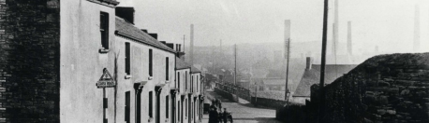
Connecting Communities to Industrial Heritage in the Swansea Valley
June 25th 2015, Swansea Museum Collections Centre, Landore, Swansea
Registration Form
Places are limited so please book using this form and return to Kate Spiller k.spiller@swansea.ac.uk or by post to COAH, Swansea University, Singleton Park, Swansea, SA2 8PP by 15th June 2015
Please complete a form for each person wising to attend.
Name ……………………………………………………………………………………………………………………………….
Postcode …………………………………………………………………………………………………………………………
Email address ……………………………………………………………………………………………………………………
Phone Number …………………………………………………………………………………………………………………
Do you have any specific language or disability requirements Yes /No
Lunch will be provided. Please indicate preferences and requirements
Vegetarian

Vegan

Gluten Free

Please tell us any allergies or other important information ………………………………………………………………………………………………………………………………………………………………………………………………………………………………………………………………………………………………………………

Thank you

