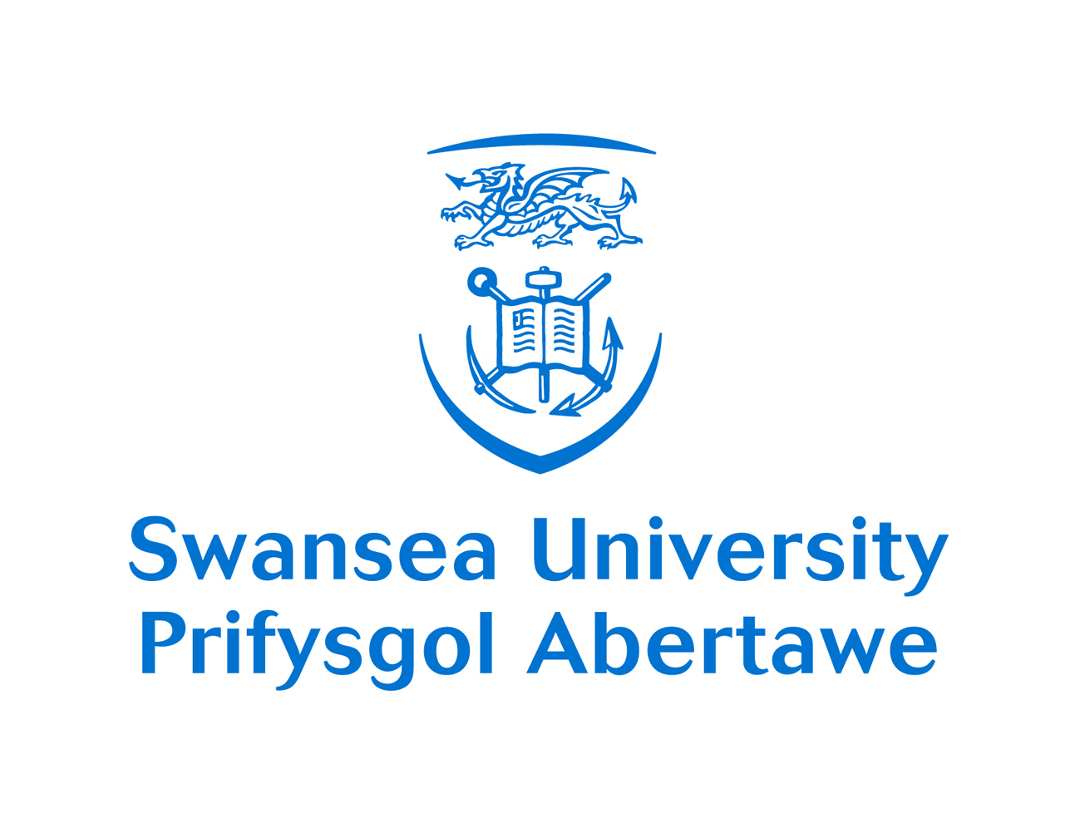

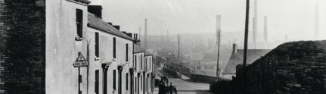

Connecting Communities to Industrial Heritage in the Swansea Valley
June 25th 2015
Swansea Museum Collections Centre, Landore

9.30 Arrivals and coffee

Part 1 – 9.45 – 10.40 Celebrating community research

Presentations including

- Celebrating community research in Swansea
- What community research means to me
- New opportunities presented by the Hafod-Morfa Copperworks development and the digital/living history laboratory
- New opportunities for connecting Copper Heritage Sites

Part 2 – 10.45 to 12.30 Consolidating existing community research projects

Workshop choices from:

    - Making the links – sharing best practice and exploring connections between community projects involved in research-based projects
    - Bringing the past to life through Performative and Interactive technology
    - Connecting Creative Communities– using creativity to engage and build community

11.25 Refreshments break

Workshop choices from:

    - Making the links – sharing best practice and exploring connections between community projects
    - Bringing the past to life through Performative and Interactive technology
    - Connecting Creative Communities– using creativity to engage and build community

12.30 LUNCH

1.25 Feedback from workshops

Part 3 Expanding community engagement in research and heritage sites

Carousel style workshops on

    - Identifying new research for the Hafod-Morfa Copperworks
    - Connecting copper (and other) heritage sites up and down the LSV
    - Identifying emerging themes for future research in the Swansea Valley

Refreshments will be available during moves between workshops

3.25 Bringing it all together. Discussion.

4.15 Close

